You have finally reached the secret base at Fjordhelm. You try to enter through the giant main door, but it is locked. You notice a keypad to the right of the door. You are about to turn away but notice a piece of paper hidden behind the keypad. It has the following information on it:

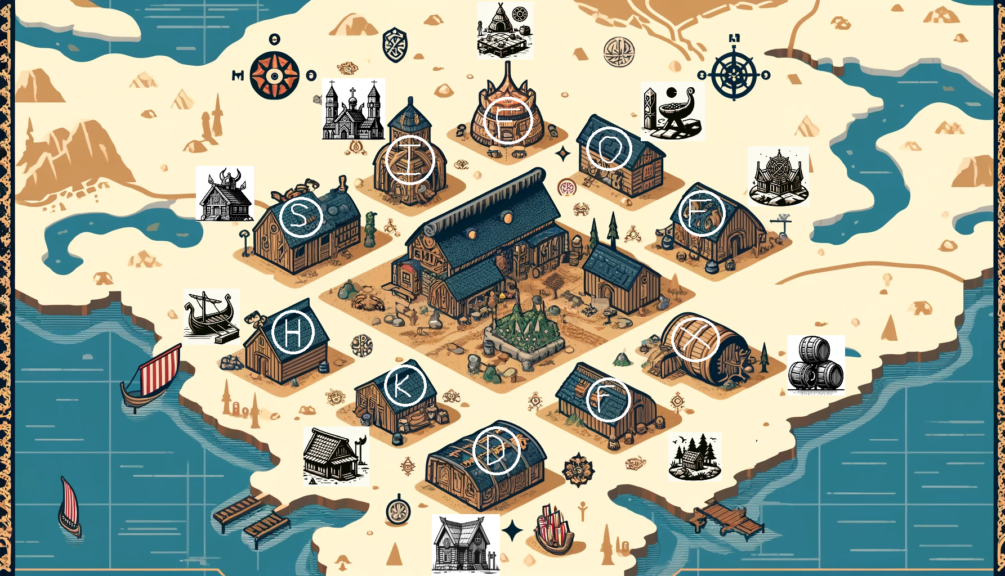

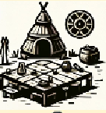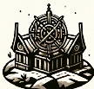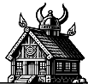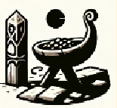

To unlock the password, you need to follow these steps

Step 1: Order the Fjordhelm locations in order of visitors per month, from highest to lowest.

Step 2: Match each location to its letter on the map

Step 3: In the same order from step one, spell out the letters, in order of visitors per month.

Step 4: Use the word wheel from your backpack to reveal the password to the base.

